Peter Banning
Graphic Designer
(123) 456-7890 | Neverland, NV 55555
peter.banning@example.com | LinkedIn | Portfolio

P R O F I L E A dynamic graphic designer with five years of experience in designing and developing visual concepts for various digital and
print media. Proficient in Adobe Creative Suite, Sketch, and
Figma. Adept at collaborating with clients and cross-functional teams to deliver high-quality designs that meet business objectives.

P R O F E S S I O N A L E X P E R I E N C E

E D U C A T I O N ^{SEP} ²⁰¹⁵ – MAY 2019
BACHELOR OF FINE ARTS IN GRAPHIC DESIGN
New York University, New York, NY

- Branding and identity
K E Y S K I L L S
- Graphic design
- Print design
- Project management
- UI /user experience (UX) design
- Visual communication

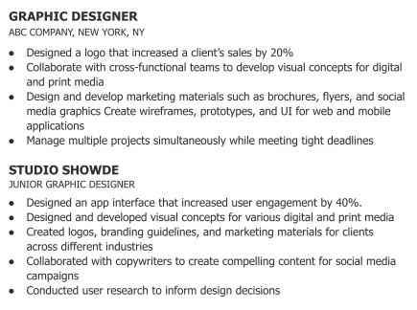

C E R T I F I C A T I O N S Adobe Certified Expert (ACE) in Photoshop Figma Certified Designer,
2019

A C C O M P L I S H M E N T S Designed a social media campaign that increased engagement by
30% for a client in the food industry
Received the “Best in Show” award at the NYU Graphic Design Senior Showcase

