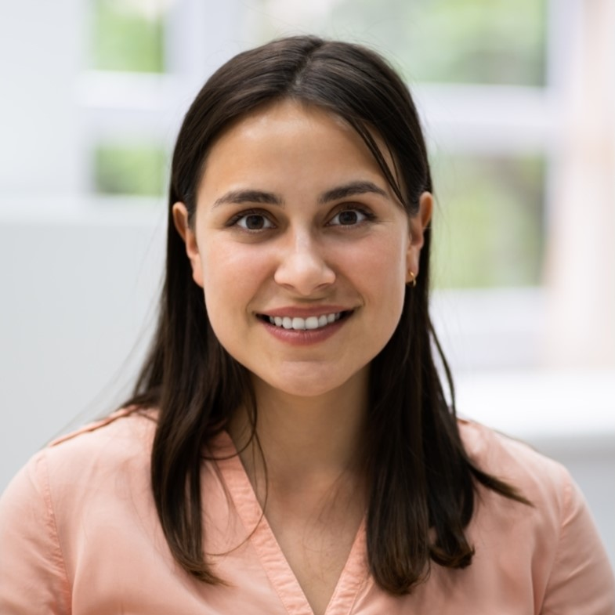 |  |  | Amanda Lopez  Experience  Certified Medical Assistant • UNC Health • Asheville, NC  November 2021 – Present  - Coordinate patient appointments for a busy dermatology department, scheduling an average of 50 appointments per day  - Develop medical assistant training modules covering clinical procedures, medical record documentation, and administrative tasks, resulting in a 30% reduction in training time  - Conduct a variety of diagnostic tests, including EKGs, pulmonary function tests, and phlebotomy, ensuring accurate results and timely communication with physicians  Certified Medical Assistant • Novant Health • Winston-Salem,NC  June 2017 – November 2021  - Conducted an average of 15 patient intake exams daily, ensuring accurate documentation and timely completion of medical records  - Received an average patient satisfaction score of 4.8 out of 5 in post-visit surveys by demonstrating exceptional patient communication and support.  - Collaborated with physicians, nurses, and other healthcare professionals to ensure coordinated patient care and efficient clinic operations  Education  Associate of Applied Science (A.A.S.) Medical Assistance  - Haywood Community College, Clyde, NC, September 2015 – June 2017  Certification  - Nationally Certified Medical Assistant (NCMA), NCCT, 2020  - Certified Medical Assistant (CMA), AAMA, 2017  Key Skills  - Medical Billing and Coding  - Medical Equipment Operation  - Office Administration  - Patient Care  - Phlebotomy
City, State Abbreviation
Zip Code
 | (123) 456-7890
 | email@example.com
 | LinkedIn | Portfolio

Profile
Compassionate and detail-oriented Certified Medical Assistant with over six years of clinical experience in a fast-paced healthcare environment. Seeking a position with Heather Valley Clinic as a Medical Assistant. Possesses exceptional communication and interpersonal skills, with a proven track record of providing high-quality patient care.

