Timothy Anderson
E X E C U T I V E A S S I S T A N T

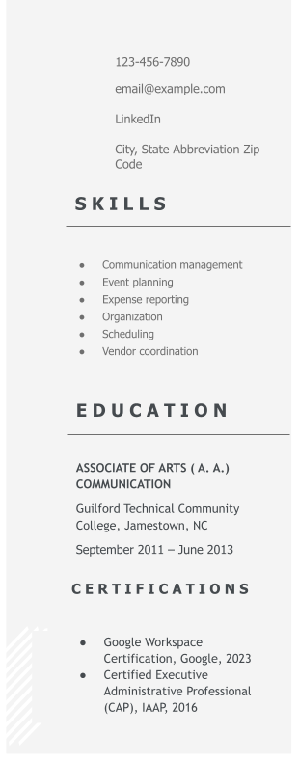
P R O F I L E

Highly organized executive assistant with nearly seven years of experience providing high-level administrative support to senior government and health care professionals. Proven track record in budget management, overseeing a departmental budget of $500,000. Strong research and data verification skills, contributing to informed decision-making processes.

P R O F E S S I O N A L E X P E R I E N C E

EXECUTIVE ASSISTANT
State of North Carolina, Wake County, NC
February 2018 – present

Supported the HR deputy director, managing incoming and outgoing communications, calendars, and travel arrangements
Managed the departmental budget of $500,000, ensuring strategic resource allocation
Maintained asset inventory and ensured compliance with procedural and operational guidelines
Tracked work assignments for staff members, achieving a 27% increase in efficiency for the Central HR Office
Conducted research and data verification to support decision-making processes Ensured accurate and up-to-date asset inventory, resulting in a 94% accuracy rate

EXECUTIVE ASSISTANT
Signify Health, Burnsville, NC
December 2016 – January 2018
Supported three executives in day-to-day activities, managing meetings, schedules, and work-related projects
Coordinated travel arrangements and worked with vendors to reduce costs by 18%
Managed expenses and submitted accurate expense reports in Concur
Collaborated with department heads regarding software, equipment, and office needs
Demonstrated confidentiality by handling sensitive information, achieving 100% compliance with data security protocols

