Danielle Collins

Dental Assistant

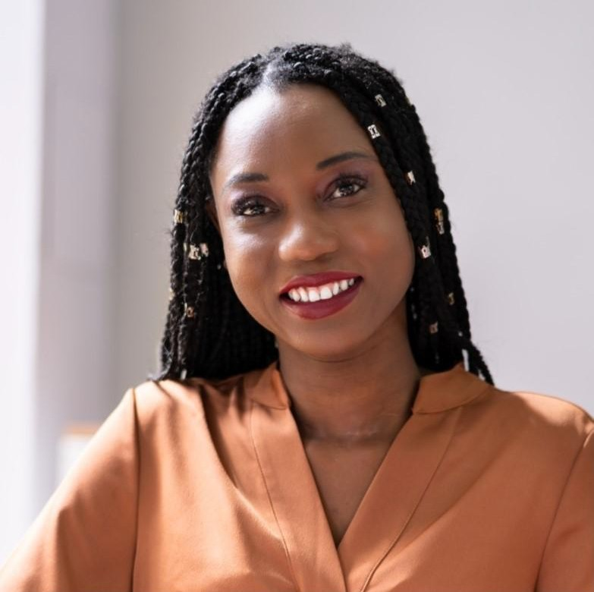
CONTACT
(123) 456-7890
email@example.com LinkedIn | Portfolio
City, State Abbreviation zip code

Profile
Certified dental assistant with over five years of experience in providing high-quality patient care and assisting dentists with a wide range of dental procedures. Skilled in taking digital radiographs, preparing patients for treatment, and maintaining accurate patient records.
Proficient in using dental software such as Dentrix and Eaglesoft. Passionate about providing exceptional patient care and committed to staying up-to-date with the latest dental technologies and techniques.

Key Skills
- Digital radiography
- Experience working with patients
- Familiarity with dental software such as Dentrix and Eaglesoft
- Infection control
- Knowledge of dental procedures

Education
Columbus State Community College, Columbus, OH | September 2014 – June 2016
Associate degree in Dental Assisting

Professional Experience
June 2019 – present
Dental Assistant | Healthy Smiles Clinic | Columbus, OH

- Assisted the dentist in over 100 dental procedures, including taking X-rays, preparing materials, and sterilizing instruments
- Educate patients on oral hygiene and post-operative care, resulting in a 20% increase in patient satisfaction
- Maintain patient records and ensure compliance with HIPAA regulations
- Manage inventory and ordered supplies as needed, resulting in a 10% reduction in supply costs
- Train new dental assistants on oﬀice procedures and protocols

December 20XX–November 20XX
Dental Assistant | Dr. Brennerʼs Dental | Columbus, OH

- Helped the dentist with more than 50 dental procedures, including taking X-rays, preparing materials, and sterilizing instruments
- Educated patients on oral hygiene and post-operative care
- Maintained patient records and ensured compliance with HIPAA regulations
- Managed inventory and ordered supplies as needed

Certifications
- Certified Dental Assistant (CDA), the Dental Assisting National Board (DANB), 2020
- Radiology certification, the Ohio State Dental Board, 2017

